RMSPROP
Root Mean Square Prop
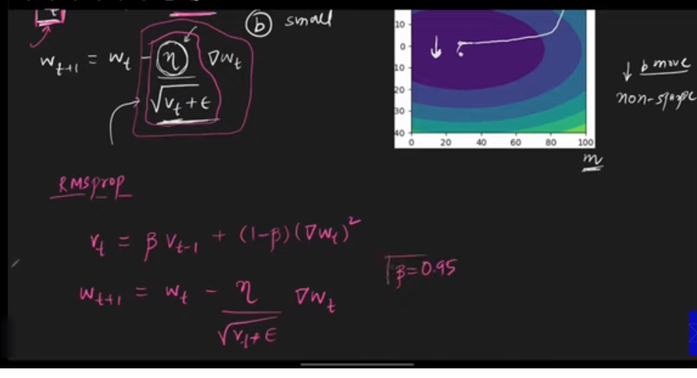
The drawback of Adagrad was that it makes the learning rate very small after a number of epochs, so RMSPROP or Root Mean Square Prop modifies the formula nad add a beta term, the value of beta term is usually kept 0.95.
Adagrad mn ham gradients ki pori history lety thy mtlb sary gradietns, likin RMSPROP mn ham Exponential weighted average lety hain or past point ky gradient ko kam value dety hain or recent walon ko zyada value.

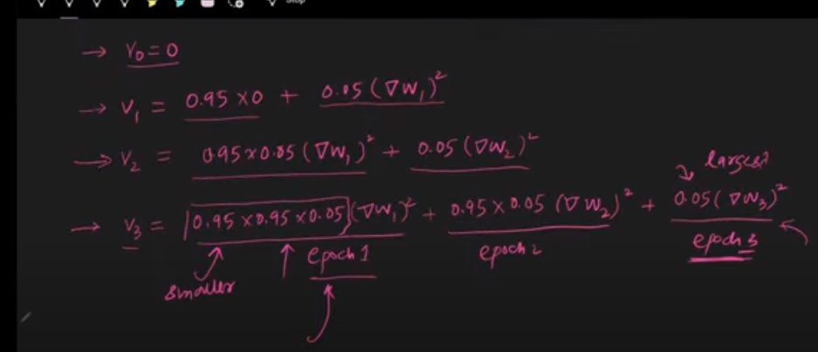
The Vt never shoots now and learning rate don’t become too small and neural network converges to the solution

Disadvantage:
RMSPROP has proven to be the best optimizer technique and it has no disadvantage. It was used the most before ADAM had came.

